**Daniel Williamson**

**Project #2**

**9/15/16**

**CS 212**

[**http://cefns.nau.edu/~daw277/index.html**](http://cefns.nau.edu/~daw277/index.html)

Project Overview

Purpose:

The purpose of this project was to explore the “Hyper” in HTML. We will be making multiple pages that will connect with one another, have images and text, have to links to various outside websites, and a link/anchor to somewhere in the middle of our text. On top of that, we will be exploring the table/form’s in HTLM to create a contact page.

Approach:

To begin this project, I reviewed our notes from class and reviewed w3schools for help on dealing with the purposes of this project. I first began by adding text and images to my page. Once, that was completed I attacked hyperlinking another websites URL into my own webpage. I decided to link Wikipedia since it contained all the information I needed about clouds. Afterwards, I set anchors throughout my website to send me to different spots within my pages. And lastly I created my contacts page using tables and forms.

Results

These are my results:

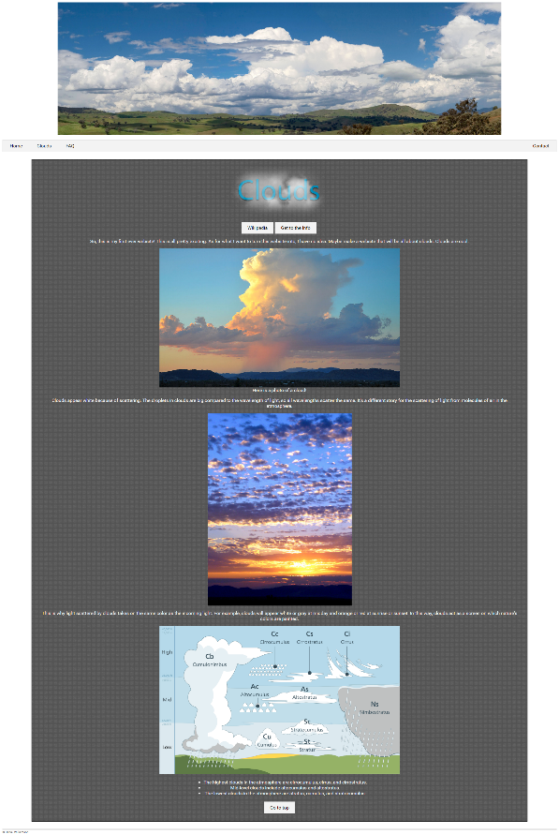

I created a navigation bar to link to each of my four other pages. I added a button to link you to Wikipedia. A button to jump to midway down the page. And lastly a button to jump back to the top of the page.

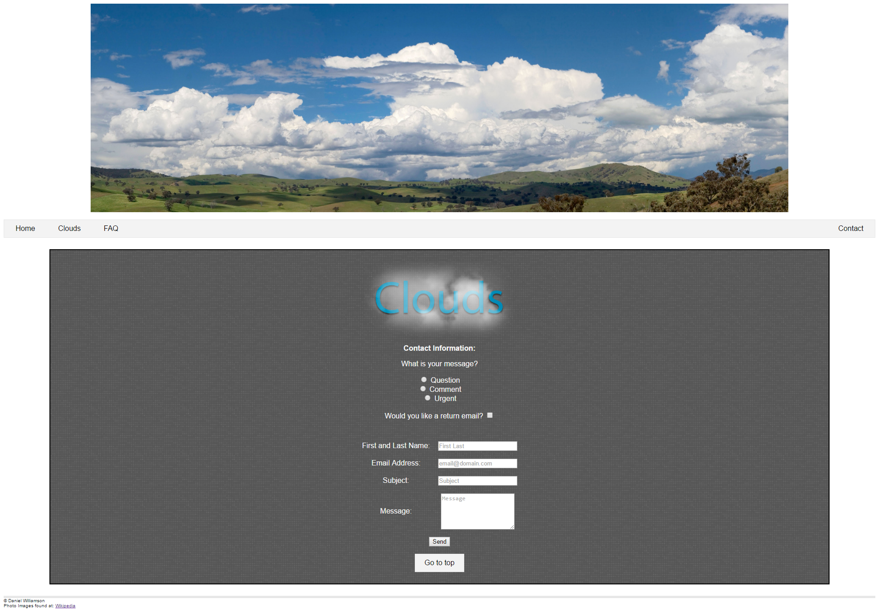

Next is my Contact’s page. I add some radio and check box buttons along with some text fields and a submit button that just refreshes the page and resets all the fields for now. I kept my navigation bar at the top to continue navigation throughout the site. I added some photos and lastly a button to shoot you back to the top of the page.

Testing:

An image before hitting the send/submit button.

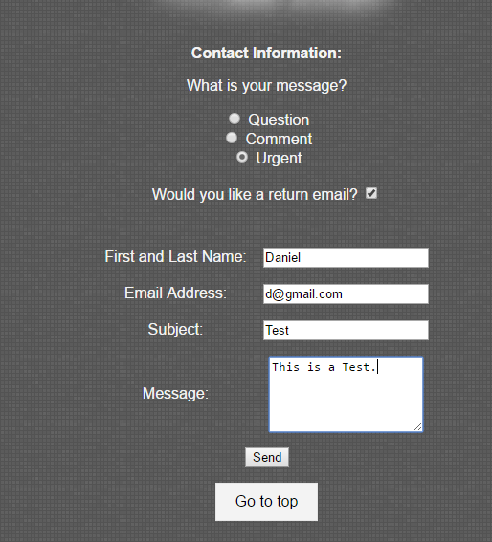

An image right after hitting the send/submit button.

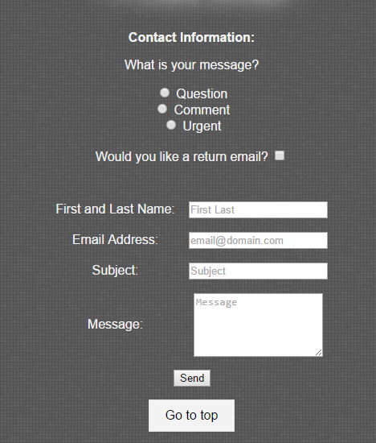

Conclusion

In conclusion this was a rather fun project. I learned a lot about HTML and how it works. I’m really excited about learning more about it and how to manipulate it into doing what I want to do. I really want to learn how to make the NavBar float with you while you scroll past it. I imagine that uses javascript and perhaps I’ll get to try it in later project. The only difficulty I had in this project was figuring out all the tables/forms for creating the radio buttons and text fields. W3schools was very helpful along with my peers. All in all, fun project and I’m looking forward to more.